
Booking a bus with Dattco.
- Go to the Dattco Booking page found here The Bus Network - Booking Widget (dattco.com)
- Complete the form and all relevant data
- Once you have completed your request, you should receive a quote via email (similar to the one below)
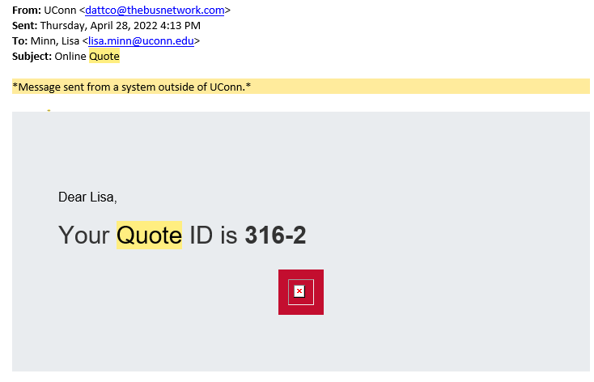
- Click on the link to open it, review it, and if okay, select Request Booking to confirm your request.
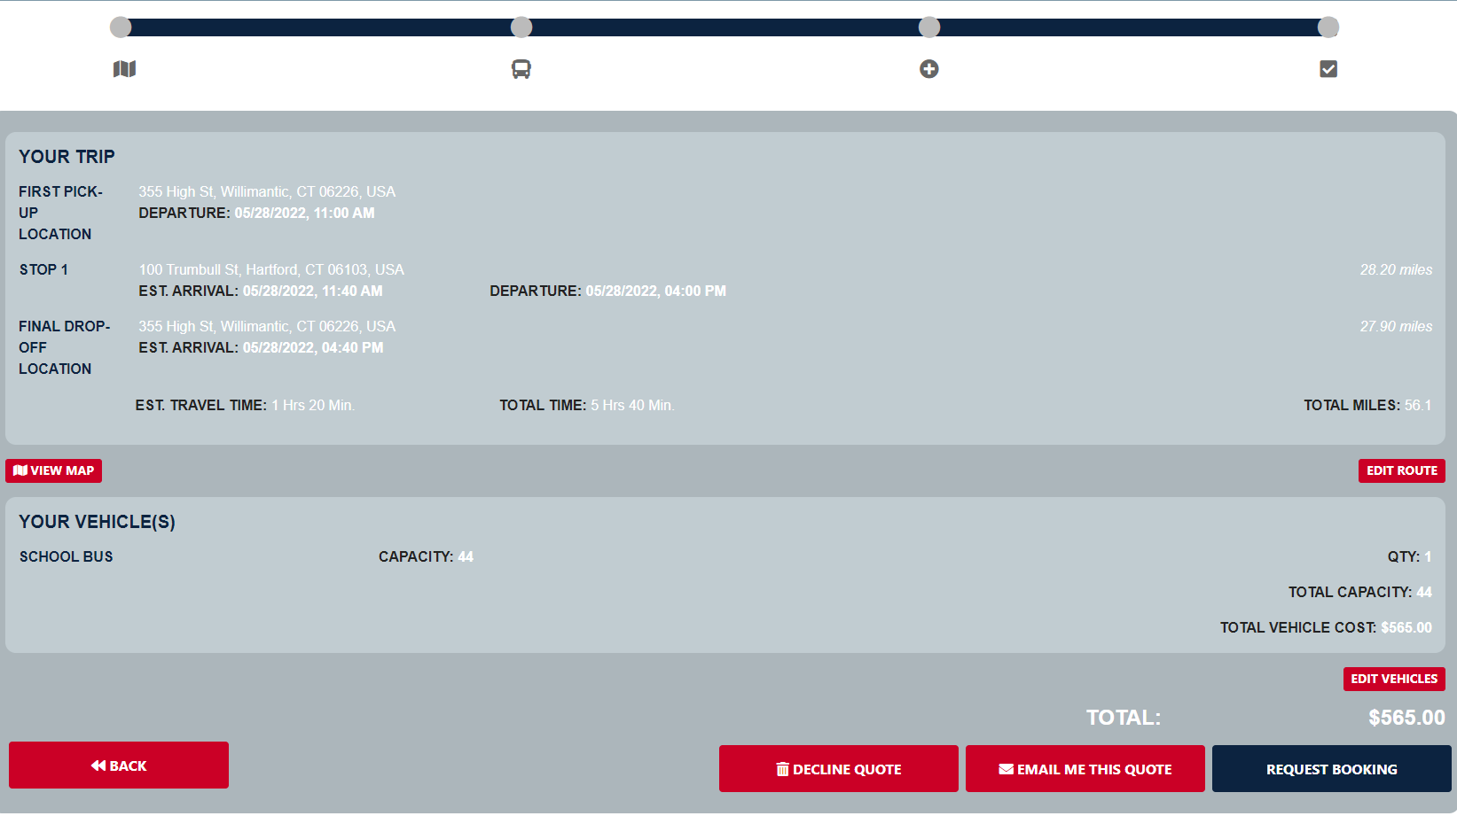
- Once finalized, you will receive a follow-up email from Dattco containing an Acceptance and also their Terms and Conditions. See example from forwarded email below.
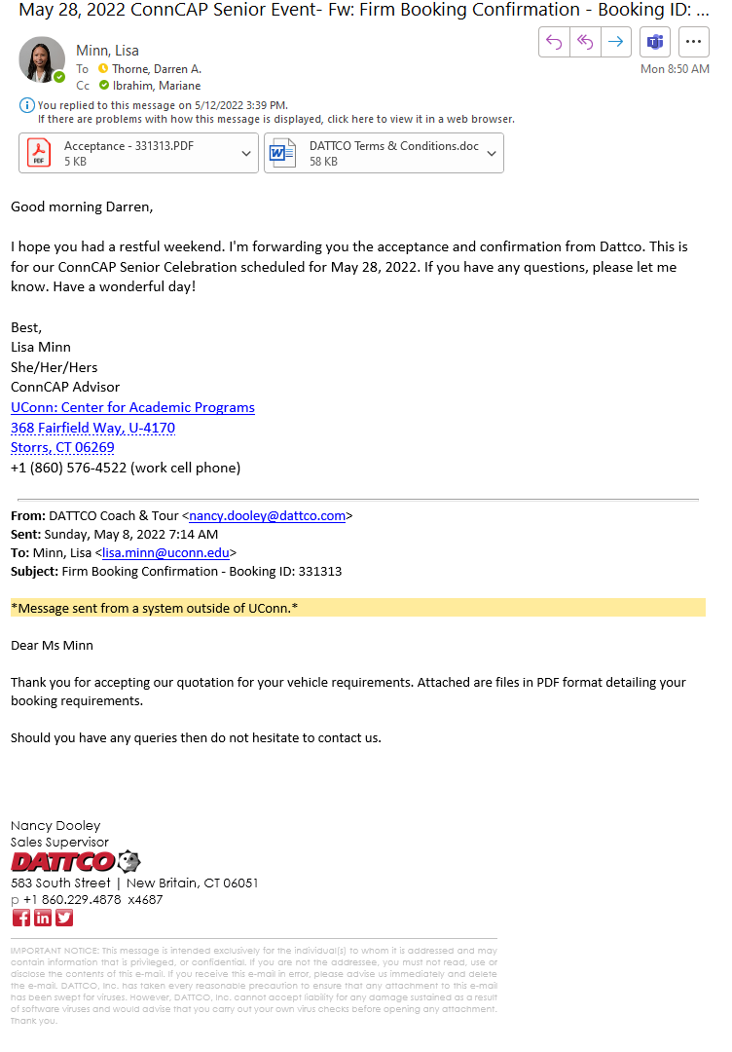
- Once you have received the Acceptance and Terms from Dattco, forward those over to me/ISS so that we can process the requisition in HuskyBuy and get a PO generated.
After the event, Dattco should email you an invoice. Once you get the invoice, please forward that to me/ISS so that I can get it over to Accounts Payable. See example of forwarded email below:
